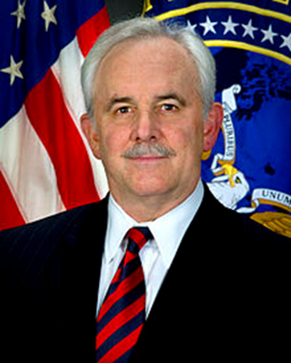

**MR. DAVID GOMPERT**

The Honorable David C. Gompert is currently Distinguished Visiting Professor at the United States Naval Academy, Senior Fellow of the RAND Corporation, and member of several boards of directors.

Mr. Gompert was Principal Deputy Director of National Intelligence from 2009 to 2010. During 2010, he served as Acting Director of National Intelligence, in which capacity he provided strategic oversight of the U.S. Intelligence Community and acted as the President’s chief intelligence advisor.

Prior to service as Principal Deputy Director of National Intelligence, Mr. Gompert was a Senior Fellow at the RAND Corporation, from 2004 to 2009. Before that he was Distinguished Research Professor at the Center for Technology and National Security Policy, National Defense University. From 2003 to 2004, Mr. Gompert served as the Senior Advisor for National Security and Defense, Coalition Provisional Authority, Iraq. He has been on the faculty of the RAND Pardee Graduate School, the United States Naval Academy, the National Defense University, and Virginia Commonwealth University.

Mr. Gompert served as President of RAND Europe from 2000 to 2003, during which period he was on the RAND Europe Executive Board and Chairman of RAND Europe-UK. He was Vice President of RAND and Director of the National Defense Research Institute from 1993 to 2000.

From 1990 to 1993, Mr. Gompert served as Special Assistant to President George H. W. Bush and Senior Director for Europe and Eurasia on the National Security Council staff. He has held a number of positions at the State Department, including Deputy to the Under Secretary for Political Affairs (1982-83), Deputy Assistant Secretary for European Affairs (1981-82), Deputy Director of the Bureau of Political-Military Affairs (1977-81), and Special Assistant to Secretary of State Henry Kissinger (1973-75).

Mr. Gompert worked in the private sector from 1983-1990. At Unisys (1989-90), he was President of the Systems Management Group and Vice President for Strategic Planning and Corporate Development. At AT&T (1983-89), he was Vice President, Civil Sales and Programs, and Director of International Market Planning.

Mr. Gompert has published extensively on international affairs, national security, and information technology. His books (authored or co-authored) include *Blinders, Blunders, and Wars: What America and China Can Learn; Sea Power and American Interests in the Western Pacific; The Paradox of Power: Sino-American Strategic Restraint in an Age of Vulnerability; Underkill: Capabilities for Military Operations amid Populations; War by Other Means: Building Complete and Balanced Capabilities for Counterinsurgency; BattleWise: Achieving Time-Information Superiority in Networked Warfare; Nuclear Weapons and World Politics (ed.);* *America and Europe: A Partnership for a new Era (ed.); Right Makes Might: Freedom and Power in the Information Age; Mind the Gap: A Transatlantic Revolution in Military Affairs*.

Mr. Gompert is a member of the American Academy of Diplomacy and the Council on Foreign Relations, a trustee of Hopkins House Academy, chairman of the board of Global Integrated Security (USA), Inc., a director of Global National Defense and Security Systems, Inc., a director of Bristow Group, Inc., a member of the Advisory Board of the Naval Academy Center for Cyber Security Studies, and chairman of the Advisory Board of the Institute for the Study of Early Childhood Education. He holds a Bachelor of Science degree in Engineering from the U. S. Naval Academy and a Master of Public Affairs degree from the Woodrow Wilson School, Princeton University. He and his wife, Cynthia, live in Virginia and Maine.